Implementation Productivity Tools Assignment
Prerequisite: Data Loader: Contact ITsupport itsupport@theblueflamelabs.com for installation and access permission related queries.

Data Loader
- Export the data of all “Project” object.
Now, run this task on schedule to automatically run every day with data destination at:
      - Dropbox for Dataloader.io
      - A location on your system for DataLoader.
Use windows task scheduler to run the batch file periodically
https://developer.salesforce.com/docs/atlas.en-us.dataLoader.meta/dataLoader/loader_batchmode_intro.htm
[Submit data exported, schedule screenshot, windows batch file, Process-config.xml]
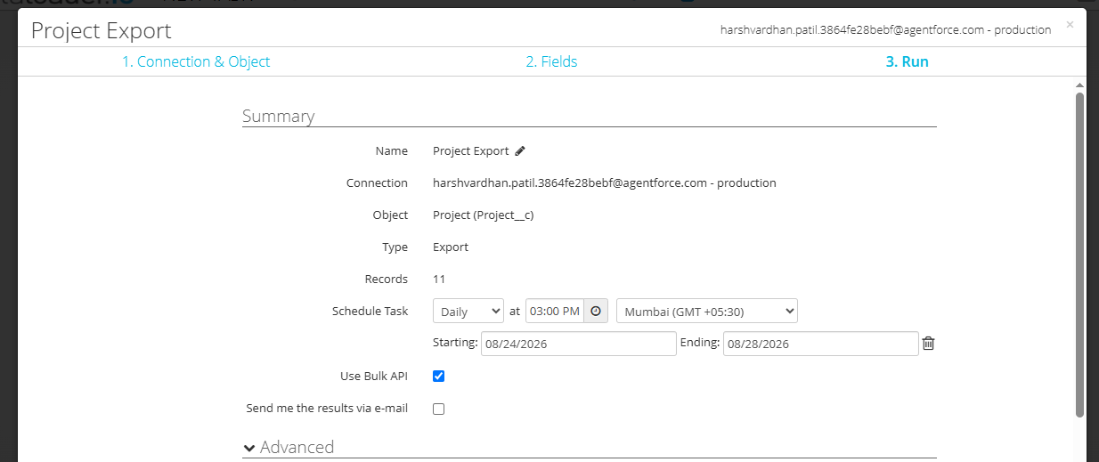
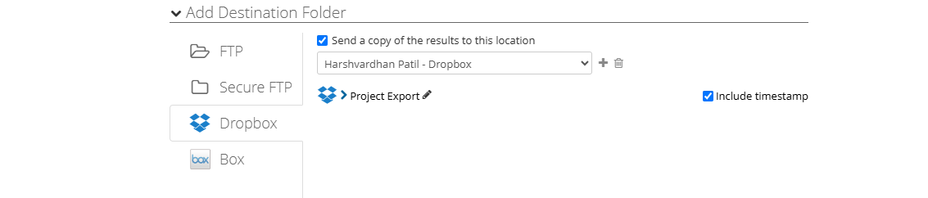
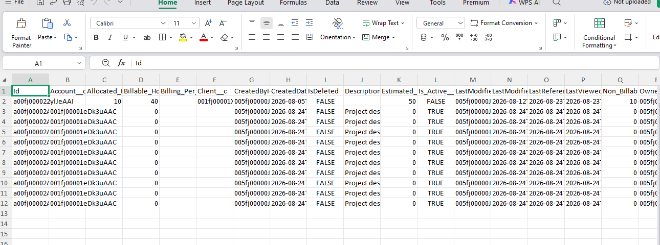
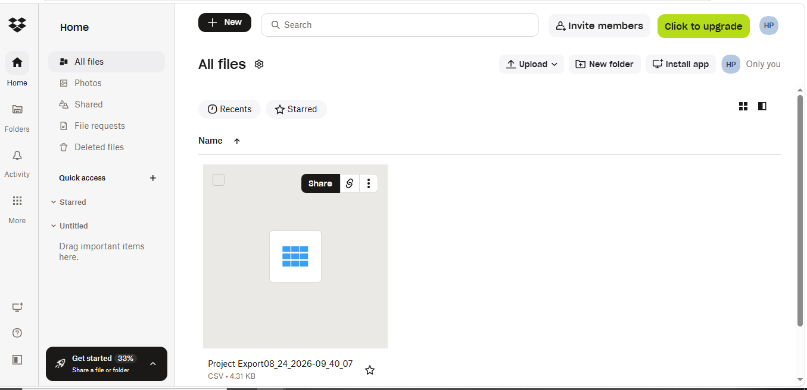
- Insert 10 new records of “Project” with same “Client/ Account” using dataloader.io.
Ensure that the following fields have been imported to Salesforce:
- Project Name (Text)
- Project start date (Date)
- Project end date (Date)
- Is Active (Checkbox)
- Description (Text Area)
- Project Status (Picklist – New, In Progress, Completed)
- Client/Account (Relationship field)
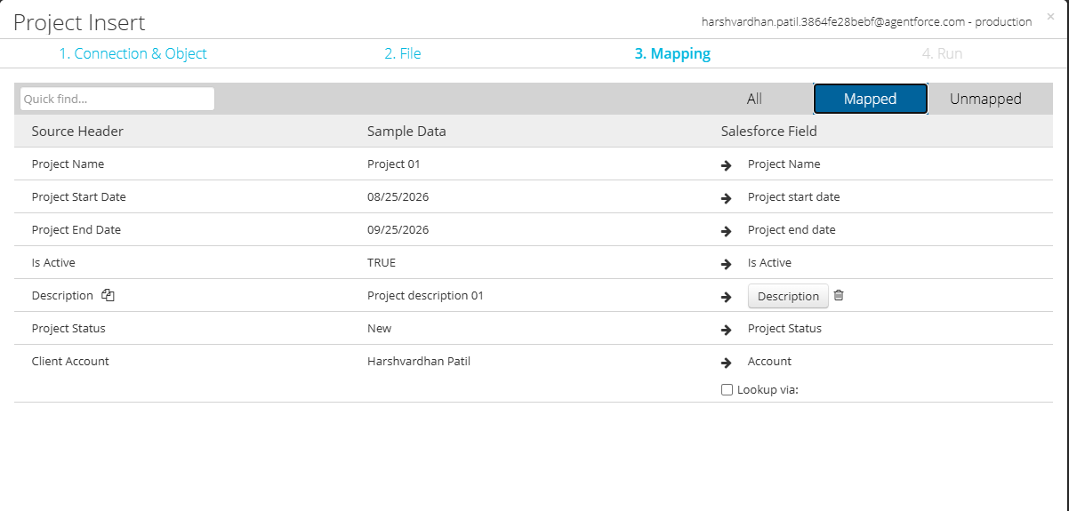
[Submit the success and error files]
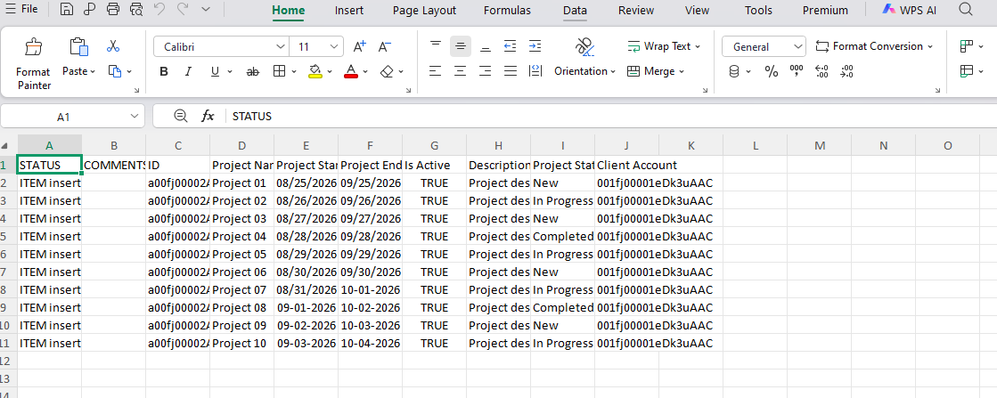
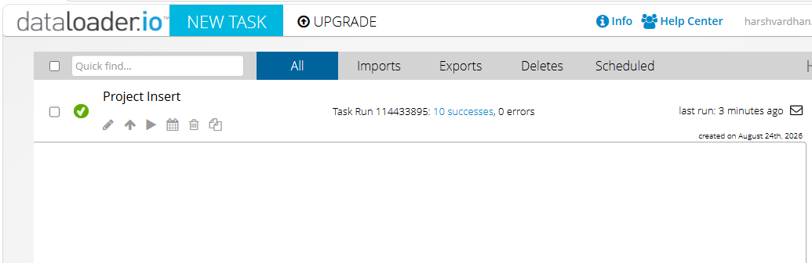
- Delete 5 records of existing contacts using an external Id field on Contact
[Submit the mapping, success and error files, screenshot of recycle bin
For Data Import Wizard, submit screenshots for each step and email
For data loader use Hard Delete instead of delete]
The above operation is not possible because To hard delete we require the record id. It cannot be deleted by the referance of external Id. And second point the data import wizard does not support delete option so we cannot perform delete operation using Data import wizard.
- Update Name field of all Project records to use first letter as capital letter using Id.
[Submit the initial data before update, mapping, success and error files post update]
Before update
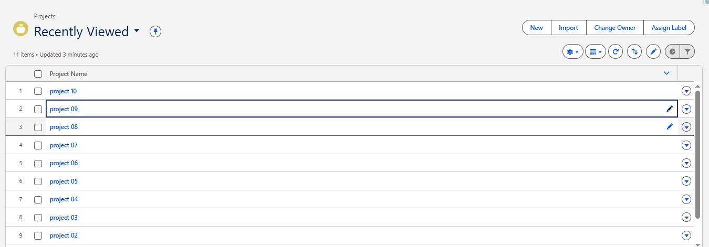
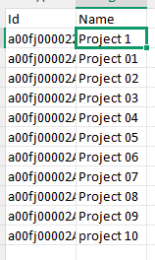
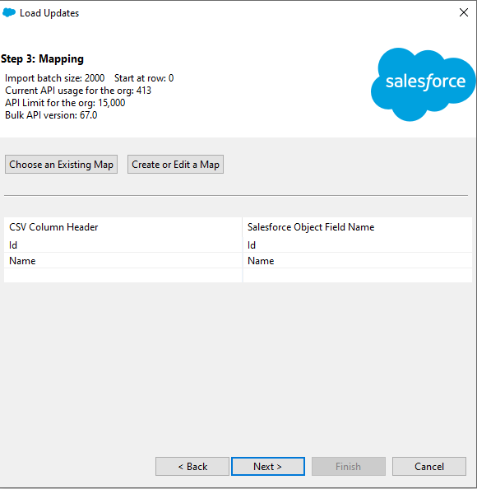
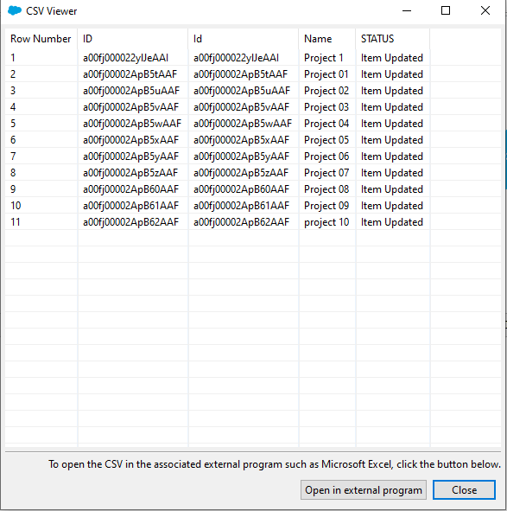
- Try the above listed operations using Data Import Wizard and DataLoader once below assignment is completed. https://help.salesforce.com/articleView?id=loader_install_windows.htm&type=5
[Submit data loader and Import Wizard screenshots for each step]

- Upsert 20 Contact records where in associated Account does not exist for at least 50% of them using data loader
Demonstrate data import into a Geolocation and Multiselect picklist field on Account
[Submittion instructions
      - Initial Input file which contains both contact and account information
      - Account Export
      - Formatted input file which contains the account id using Vlookup function of excel
      - Account import results
      - Updated Contact file which has all account id’s
      - Mapping file
      - Success and Error file]
- Creative Consulting would also use the standard Cases object to track all previous Cases on Salesforce. All closed cases should be assigned to the Reviewer (User) – Min 5.

(Hint: Use Assignment rules in context with Data Loader)
- What is the difference between Export and Export All option in Data Loader?
In Salesforce, Export gets only active live records from an object. Export All gets active records plus deleted items in the recycle bin (soft-deleted records) and archived activity records
- What is the difference between Delete and Hard Delete option in Data Loader?
In a standard Delete moves records to the Recycle Bin where they stay for 15 days and can be restored. A Hard Delete bypasses the Recycle Bin entirely, deleting the records for good right away.
[Answer to theory questions need to be submitted along with DSR else no marks will be provided]

